
PRESSBOOK

This Summer's most pleasant film festival.
• Karolina Pasernak, “Przekrój”

The idyllic Kazimierz could have easily made the TWO RIVERSIDES festival seem like a typical holiday event. Luckily, that did not happen and the person we have to thank for it is Grażyna Torbicka, who decided to aim at outstanding cinema and demanding guests, and who was rewarded with a great, receptive audience.
• Danuta Majka, “Gazeta Wyborcza”

A retrospective of Carl Theodor Dreyer is the revelation of the Two Riversides festival in Kazimierz and Janowiec.
• Tadeusz Sobolewski, “Gazeta Wyborcza”

Kazimierz has become an obligatory stop on the vacation track of cinema-lovers visiting Summer festivals. (...) A holiday of film variety.
• Wojciech Kałużyński, „Dziennik”

Two Riversides escape the comparison with any other film festival in Poland.
• Łukasz Muszyński, FilmWeb

Deciding on a venturesome retrospective of Dreyer’s films in Kazimierz, Grażyna Torbicka also ran a great risk. Her festival, Two Riversides, is evolving in a very interesting direction, which should only make us happy.
• Krzysztof Siwczyk, “Polityka”

Films are not the only strong point of this event. An equally interesting part were the “Cinema Lessons,” the confessions of a film-maker, the title of which can be taken literally!
• Emilia Chmielińska, Interia.pl

Ladies and Gentlemen
For the fifth time already I have the pleasure to invite all enthusiasts of good cinema to the Film and Art Festival TWO RIVERSIDES in Kazimierz Dolny and Janowiec by the Vistula River. This edition, like the previous ones, offers a completely original programme which we create with the belief that life with art and culture makes us more beautiful.
Year after year, the previous editions of the festival have proven that the audience coming to TWO RIVERSIDES like being surprised and are curious of the world and of other people. We are not a big festival when it comes to the number of screenings but we guarantee the satisfaction from contact with art and many artists, from leisurely conversations and meetings. SLOW FILMMOOD is something that we really miss in everyday life! Tried, unchanging sections: “World Under Canvas,” “Music, My Love,” “In the Short Run,” “Great Cinema On Small Marketplace,” in which one can find films chosen in festivals worldwide, feature films and documentaries, often presented in Poland for the first time.
What is new this year is a perspective under the slogan of Viaggio in Italia and the retrospectives of Roberto Rosselini, Loliana Cavani, and the Literature and the Screen section will show films based on the books of a Sicilian writer, Leonardo Sciascia. And one more new, interesting trend that we do not know so well: “mockumentaries”, films which use the form of a documentary film to tell stories that are not always documental, among them also films from the so-called “found footage” trend.
The musical opening is, for the first time in Poland, a concert of DANIEL MELINGO. This cult artist from Argentina will, together with the band, perform compositions from his last two albums: Santa Milonga and Maldito Tango.
I invite You to the LITTLE GREAT FESTIVAL in Kazimierz and Janowiec from 30th of July to 7th of August.

Grażyna Torbicka – Artistic Director TWO RIVERSIDES Festival

Film and Art Festival TWO RIVERSIDES
- Viaggio In Italia!
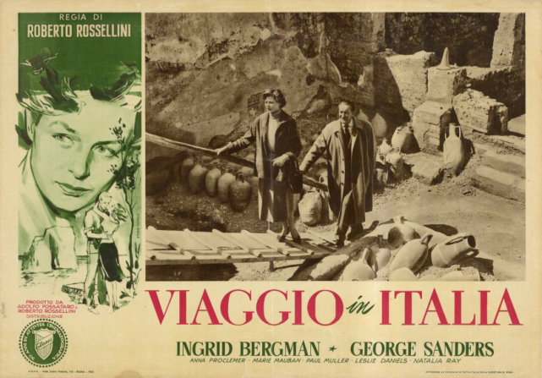
During he 5th edition on the Film and Art Festival TWO RIVERSIDES we invite you to follow the steps of Italian artists. From 30th of July to 7th of August we will be accompanied by the slogan “Viaggio In Italia.” “Journey to Italy” is the title of a film by ROBERTO ROSSELLINI, one of the main creators of the Italian neorealism. This fully unconventional director experimented with new forms and techniques. His films became an inspiration for following generations of European artists. Andre Bazin, Francois Truffaut, Jean Luc Godard recognised him as the godfather of „Nouvelle Vague.” Scorsese, inspired by “Viaggio In Italia,” made “Il Mio Viaggio In Italia,” the Taviani brothers’ inspiration to make documentaries came from the film “Paisa.” Watching Rosselini's “Stromboli, God’s Land,” Jean-Marie Maurice Schérer took on the pseudonym Eric Rohmer and “relclaimed himself” from philosophy to cinema.

- OPENING CONCERT - Daniel Melingo
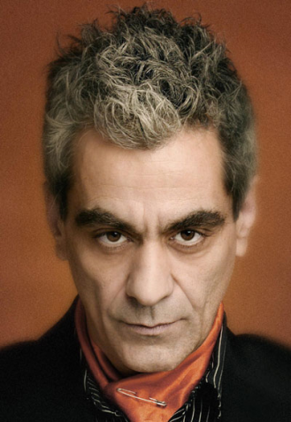

The Argentinean artist will perform in Poland for the first time. He will perform compositions from his last albums: “Santa Milonga” and “Maldito Tango.” He is perceived as a Latin-American Tom Waits.

- This year, the Festival program will include, among others:

- Retrospective of Roberto Rosselini – the master of Italian neorealism.

- Retrospective of Liliana Cavani – a director and scriptwriter, who in her films undertook the political topics in a revolutionary way. Her debut, “Francis of Assisi,” was an expression of her fascination with Rosselini. The films which will be shown during TWO RIVERSIDES include: The Night Porter (Charlotte Rampling, Dirk Bogarde), The Skin (Marcello Mastroianni, Claudia Cardinale, Burt Lancaster).

- Retrospecive of Andrzej Kondratiuk – the only representative of neorealism in Poland.

- And God created the actor. Zbigniew Zamachowski
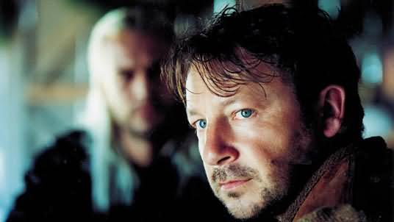
Our guest will be Zbigniew Zamachowski, who is turning 50 in 2011. A remarkable theatre and film actor, an exquisite song interpreter and a great pianist, poet and composer. He starred, among others, in the films of Kazimierz Kutz (Pułkownik Kwiatkowski / Colonel Kwiatkowski, Zawrócony / Reverted, Sława i chwała / Fame and Glory), Krzysztof Kieślowski (Dekalog X / Decalogue X, Trzy kolory: Biały / Three Colours: White), Andrzej Wajda, Jacek Borowski, Maciej Wojtyszka, Filip Bajon and Wojciech Marczewski. He has been repeatedly awarded in Poland (Wiktors ‘93 and ’96, Złota Kaczka / Golden Duck ’93, Berdini Award ’97) and abroad; in short: “The Divine Zamachowski!”

During TWO RIVERSIDES, he will personally present a choice of film and theatre roles. The series will be complemented by meetings with the actor, his friends and co-workers.

Three years ago the TWO RIVERSIDES Festival initiated a retrospective of great actors' eminent creations. The guests we have had so far are: Janusz Gajos, Krystyna Janda and Jerzy Stuhr.

- Cinema Lesson – the confessions of a film-maker

“Cinema Lesson” is a particular form of our special guests' meeting with the festival audience. In a very personal way, the artists talk about their fascination with art (not only film art), inspirations, masters and mentors, but also about the sins they have committed along their artistic way. These meetings not only show the profile of the artist, they also provoke a very interesting discussion about the system of values, philosophy of life, the role of culture and art in everyday life.
Among those who have accepted the invitation to this year's series is Grzegorz Królikiewicz.

He is a restless and disquieting spirit of Polish cinema, an artist who roams in the search of the one and only ‘true’ path both for the soul and for art.
Maria Kornatorska (“Film,” 41/1986)
Grzegorz Królikiewicz – Polish director and film scriptwriter, pedagogue; author of many books and essays on the history of cinema. In 1976-78, he was the editor-in-chief of Fakt in TV. Later, he was he artistic manager of the “Aneks” Film Team. Since 1981, he has been a research worker at PWSFTviT (National Higher School of Film, Television and Theatre) in Łódź, where he was titled full professor in 1997. He also taught at the University of Łódź, at the Radio and Television Department of the University of Silesia, in the Melchior Wańkowicz School of Journalism, and at the Cracow Scriptwriting School. Since 1969, he has realised several dozen documentary films and splendorous spectacles of television theatre. As a creator of feature films, he debuted in 1972 with the famous film “Na wylot” / “Through and Through]. Grzegorz Królikiewicz received numerous awards, such as the Golden Lions during the Polish Feature Film Festival, the Lajkoniks during the Cracow Film Festival, awards during festivals in Mannheim, Karlove Vary, Montecatini or Panama.
The festival program includes a mini review of Grzegorz Królikiewicz’s films: “Zabicie ciotki” (“Killing Auntie”), “Fort13,” “Na wylot” (“Through and Through”). Every screening will be preceded by the author's personal commentary and a chosen short film. After the screening of “Na wylot” (“Through and Through”), the finale will take place on the 4th of August (Thursday), and it will be the Cinema Lesson – the confessions of the artist Grzegorz Królikiewicz.
Since 2009, the Cinema Lessons have been recorded and constitute a part of the Film and Art Festival TWO RIVERSIDES archive. As a part of the series we have already hosted: Bob Rafelson, Bruno Barreto, Sławomir Grünberg, Wojciech Marczewski, Andrzej Titkow, Jerzy Stuhr, Sławomir Idziak, Piotr Szulkin, Filip Bajon, Jan Hrebejk.

- CINEMA BETWEEN THE LINES

At TWO RIVERSIDES, we give much attention to the relationship between literature and cinema. During the first edition we observed the romance between cinema and literature in the work of Jiří Menzel based on the prose of Hrabal. During the trip to Italy, the film-literary hero will be LEONARDO SCIASCIA. This poet and Sicilian prose-writer portrays modern Italy in a unique way. In his stories we get to know everyday life in this country, and in this mundane context we can find a socio-political philosophical analysis. His novels seem to be ready-made film scripts, and for that reason they have been screened so often. Apart from a debate on his work with Polish poets and writers, we will also see a selection of his films which are based on the prose of Leonardo Sciascia:
- „The Day of the Owl” directed by D. Damiani
- “To each his own” directed by E. Petri
- „Cadaveri Eccelenti” directed by F. Rosi

We will also trace the Italian inspirations in the works of Czesław Miłosz, Gustaw Herling Grudziński, Adam Zagajewski.

- INDEPENDENT SHORT FILMS COMPETITION changes its formula

This time amateurs and students will compete with professionals and film school graduates. It is the most important change that the Programme Division have decided to introduce into the Contest rules. “After three years we can safely say that the performance level of young artists is very high, so we have decided to broaden the formula of the contest: this year, films by authors who have not yet created a feature length film can be submitted.” - explains Ania Stadnik, Head of the Programme Division.

Films which enter the ISFC are feature films, documentaries, animations ad experimental films that last up to 60 minutes and were produced in 2010 or 2011. Older films can (only conditionally) be admitted if their screening during the Festival will be their first presentation in Poland. 27.05.2011 is the deadline for all applications.

Taking part in this competition not only gives the opportunity to be shown on the big screen but also to confront one’s ideas with the most difficult and demanding jury: the audience. In the Short Films Competition the films are judged by an Independent Jury chosen from the festival audience.

The main prize of the ISFC is 3000 zlotys. There are also two additional prizes: directors will get 1000 zlotys each.

In the Short Films Competition works are assessed by an Independent Jury selected from the festival audience: Applications will be accepted from 01.06.2011 to 15.06.2011. More info: www.dwabrzegi.pl

Shorts will be shown before the feature length films. We are calling for this short time before the show to be returned to the Young!

The awards that our Independent Jury gave in the previous years are as follows:
TWO RIVERSIDES 2008
• Main Prize – Jakub Stożek „No Place for Fall”
• Additional Prizes: Agnieszka Smoczyńska „Aria Diva” and Jakub Wroński „American Dream”
TWO RIVERSIDES 2009
• Main Prize – Bartek Cierlica "The Gravediggers"
• Additional Prizes: Erika Janunger "Weightless" and Balbina Bruszewska "The City Sails on"

TWO RIVERSIDES 2010
• Main Prize – Kuba Czekaj „Don't Be Afraid of the Dark Room”
• Additional Prizes: Ivo Krankowski „8 Stories (That Haven't Changed the World)” and Julia Kolberger „Tomorrow I'll Be Gone”

- THE AUDIENCE POLL
At the Film and Art Festival TWO RIVERSIDES the most important and only jury is the audience. It is they who choose the best film by voting in the Audience Poll, which has been a part of TWO RIVERSIDES since its first edition. Films which take part in it are ones from the “World Under Canvas” and “Documentary” sections and feature film premieres from other sections produced in 2010 and 2011. The audience votes on special coupons grading the films on a scale from 1 to 5. The results of the Audience Poll are announced on the last day of the festival. The viewers taking part in the Poll can apply to take part in the workshops during the MFF in Venice, to which TWO RIVERSIDES’s partner invites each year. The person wishing to apply has to fill the voting coupon correctly and give his/her contact information on the back side of the coupon. The drawing takes place during the festival's official closing gala.

ACCREDIATIONS TO the TWO RIVERSIDES Festival:
The Press Office is waiting for the accreditation applications from 14th of June.
All details are available at www.dwabrzegi.pl

